Chapter 3

REQUIREMENTS ANALYSIS AND DESIGN OF THE SYSTEM

Functional Requirements

This chapter will exhibit the feature of the Collaborative Code Learning Environment using MERN stack of what are the input, the execution procedure of the processes, and output of the system.

Inputs:

The following are the inputs:

* User
* Update user information
* Input email and password
* Add programming language
* Set appointment
* Code editor
* Audio Input
* Video Input
* Chat Box Input
* Rate user

Process:

* User Authentication
* Registering a user
* Generate Classroom Code
* Set Appointment
* Computation of Commissions
* Computation of Payment

Output:

The following are the outputs:

* Master list
* Rating for the other user
* Appointment
* Code Editor Output
* Audio Output
* Video Output
* Chat Box Output

Non-Functional Requirements

The information system is expected to perform the following functional requirements:

* The system should validate email and password when logging in
* The system should provide a unique link automatically for the collaboration schedule.
* The system should confirm and store the user account when registering without the action of the administrator
* The system should send an email link for account confirmation
* The system should process and confirm payment
* The system should store, display the ratings and comments of the users
* The system must send notification automatically if there’s an appointment request

Usability Requirements

Information System users have the following characteristics:

* The user must be computer literate and knowledgeable in using the system
* The user must be caution in accepting the appointment request. It will not undo the process.
* The user must be responsible and sincere in requesting appointment to another user.
* The user must be caution in processing and confirming the payment. It will not undo the process.
* The user must choose a rating sincerely to completely end the collaboration on another user.

Class Model

A class model is a standard UML diagram, which visualizes graphical representation of the structure of the system and it also has a relation between the objects and classes of the system. Each of the object in the system has a data structure and behavior. Object that shares the same features are grouped into a class.

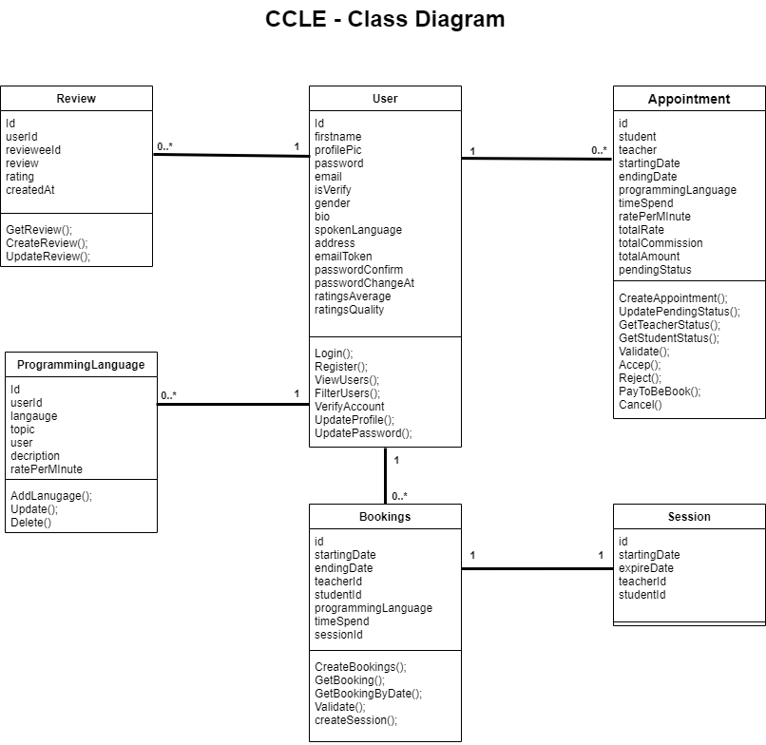

Figure 3. Class Diagram of Collaboration Code Learning Environment Using MERN STACK

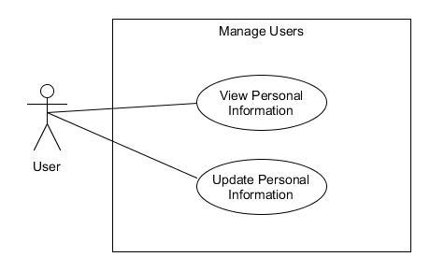System Use Cases

Figure 4. System Use Case of Manage Users

Use Case Description

Use Case Name : View Personal Information

Purpose : To view user information

Triggering Actor : User

Benefiting Actor : User

Pre-Condition : The user wants to view the personal information

Post-Condition : The system automatically view the personal information

|  |  |
| --- | --- |
| User | System |
| 1. Click the user’s profile picture on the navigation.   3.) Clicks the ‘Profile’ link | 2.) Sub menu will show up with the clickable links [Profile, My Account, Logout].  4.) Renders the “Profile” page showing all the information about the user. |

Use Case Description

Use Case Name: Update Personal Information

Purpose : To update the user personal information

Triggering Actor : User

Benefiting Actor : User

Pre-Condition : The user wants to update user personal information

Post-Condition : The system will automatically update the user personal information

Steps:

|  |  |
| --- | --- |
| User | System |
| 1. Click the user’s profile picture on the navigation.   3.) Clicks the ‘My Account’ link.  5.) Changes the information that wants to update. 6.) Clicks the Update button. | 1. Submenu will show up with the clickable links [Profile, My Account, Logout].   4.) Renders the “Account Setting” page showing all the editable information about the user.  7.1) If the user clicks the update button is true, then the system will show a message that the user successfully updates the user profile else  7.2.) The system will disregard and cancelled the changes. |

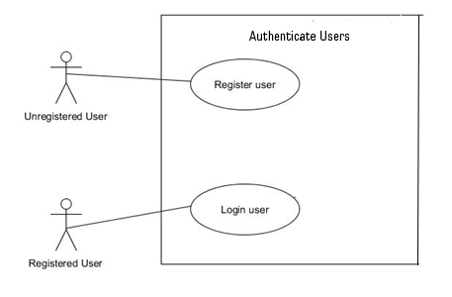

Figure 5. System Use Case of Authenticate Users

Use Case Description

Use Case Name: Register user

Purpose: To authenticate user in registering an account

Triggering Actor: Unregistered user

Benefiting Actor: Unregistered user

Pre-Condition: The user will input the information required in registration

Post-Condition: User successfully register

Steps:

|  |  |
| --- | --- |
| Unregistered user | System |
| 1. Click Register button on the navigation   3.) Enter first name, last name, gender, email, password, confirm password  4.) Click the Signup button | 1. Load Register UI Form   5.) The system will authenticate the validity of user identification to the system.  5.1 If the user identification is valid, then the user successfully register and user will redirect to “Account Settings” and pop up a message “Your account is not verified yet!”. We've sent you an email. Please check your email to verify your account!” together with a button where a user a has an option to logout. The user will be added to system database else  5.2 The system will show a message “Error: Please check the information you provided”. The user will remain to the page for further changes. |

Use Case Description

Use Case Name: Login user

Purpose: To authenticate user in logging in.

Triggering Actor: Regular User

Benefiting Actor: Regular User

Pre-Condition: The user will input the information needed in logging in

Post-Condition: User successfully log in

Steps:

|  |  |
| --- | --- |
| Registered user | System |
| 1. Click Login button on the navigation   3.) Enter email and password  4.) Click the Login button | 1. Load Login UI Form   5.) The system will authenticate the validity of user identification to the system.  5.1 If the user identification is valid, then the user successfully login the account and the user will proceed to user “Profile” page else  5.2 The system will show a message “The email or password were incorrect. Please try again”. |

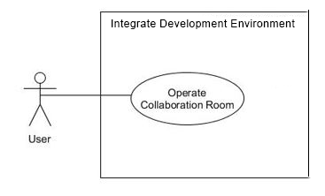

Figure 6. System Use Case of Integrated Development Environment (IDE)

Use Case Description

Use Case Name: Operate Collaboration Room

Purpose: To have collaboration tutor to another user

Triggering Actor: User

Benefiting Actor: User

Pre-Condition: The user will pay for the collaboration

Post-Condition: The user will proceed to collaboration

Steps:

|  |  |
| --- | --- |
| User | System |
| 1. The user will pay for the collaboration tutor to another user. 2. The user clicks the Collaboration Link sent by an email or inside the booked appointment. | 3.) The user will redirect to the link and open the Collaboration Room. |

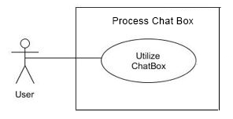

Figure 7. System Use Case of Chat Box

Use Case Description

Use Case Name: Utilize Chat Box

Purpose: To send and receive a message to another user

Triggering Actor: User

Benefiting Actor: User

Pre-Condition: The user will enter messages and send it to another user.

Post-Condition: The message will send and shown on chat box.

Steps:

|  |  |
| --- | --- |
| User | System |
| 1. The user will pay for the collaboration tutor to another user. 2. The user clicks the Collaboration Link sent by an email or inside the booked appointment.   4.) Clicked the Chat Box toggle button.  6.) The user will type a message and clicked the Send button. | 3.) The user will redirect to the link and open the Collaboration Room UI.  5.) Chat Box UI will load.  7.) The system will process and sent the message to another user.  7.1 If message sent is true, the message will be showed to another user else  7.2 The system will not send the message to another user. |

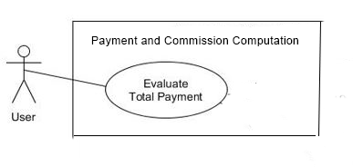

Figure 8. System Use Case of Payment and Commission Computation

Use Case Description

Use Case Name: Evaluate Total Payment

Purpose: To show the total payment bill of the user

Triggering Actor: User

Benefiting Actor: User

Pre-Condition: The user will click pay button

Post-Condition: The user will view the total amount to pay and system’s commission.

Steps:

|  |  |
| --- | --- |
| User | System |
| 1. Click Find Tutor in the navigation 2. A user will choose a teacher and click ‘View Profile’ button      1. Click the ‘Set Appointment’ button   5.) The user will set programming language, set date and time, and chose the number of minutes by Slider. | 3. Renders the teacher’s profile page.  4.) A Form will pop with 3 inputs for the user: Dropdown menu, where a user can choose what programming language a user wants to learn or discuss. Date and Time picker, for choosing what starting date and time a user wants to be scheduled, and a Slider where a user can choose a number of minutes and calculate the total amount to pay by the user and the total system’s commission.  6. The system will view the total amount to pay by the user together with the system’s commission. |

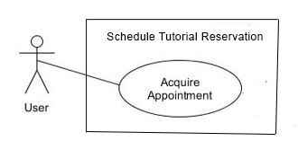Figure 9. System Use Case of Schedule Tutorial Reservation

Use Case Description

Use Case Name: Acquire Appointment

Purpose: To reserve a schedule for collaboration appointment

Triggering Actor: User

Benefiting Actor: User

Pre-Condition: The user will must be accepted and process the payment

Post-Condition: The user successfully reserve a schedule for collaboration.

Steps:

|  |  |
| --- | --- |
| User | System |
| 1. The other user will accept the appointment request. 2. The user clicks the “Pay Now” button.   4.) The user will clicks “Pay” button. | 3.) The system displays the Total Amount to pay for the collaboration.  5.) The system will process, approve the payment and the system will save the schedule of the user. |

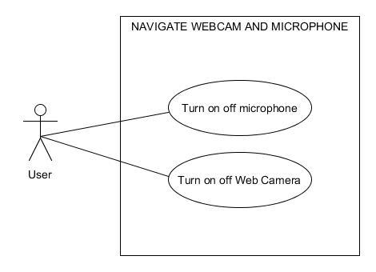

Figure 10. System Use Case of Navigate Webcam and Microphone

Use Case Description

Use Case Name: Turn on or off microphone

Purpose: To enable or disable user microphone

Triggering Actor: User

Benefiting Actor: User

Pre-Condition: The user will speak to another regular user

Post-Condition: The user can communicate to another regular user

Steps:

|  |  |
| --- | --- |
| User | System |
| 1. Clicked the Collaboration Link   3.) The user clicks the Audio toggle button | 2.) The user will redirect to the link and open the Collaboration Room  4.) The system will turn on or off the microphone input of the user  4.1 If microphone input of user will turn on is true, the user allowed the system to access the microphone and will be audible on another user else  4.2 The microphone input of the user will remain turn off and inaudible to the other user. |

Use Case Description

Use Case Name: Turn on or off Web Camera

Purpose: To enable or disable user microphone

Triggering Actor: User

Benefiting Actor: User

Pre-Condition: The user will speak to another regular user

Post-Condition: The user can communicate to another regular user

Steps:

|  |  |
| --- | --- |
| User | System |
| 1.) Clicked the Collaboration Link  3.) The user clicks the Video Camera toggle button | 2.) The user will redirect to the link and open the Collaboration Room.  4.) The system will turn on or off the camera.  4.1 If video camera will turn on is true, the user allowed the system to access the camera and viewed on another user else  4.2 The video camera will remain turn off and inaccessible to the other user. |

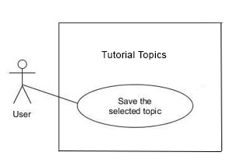Figure 11. System Use Case of Tutorial Topics

Use Case Description

Use Case Name: Save the selected topic

Purpose: To set a topic for tutorial

Triggering Actor: User

Benefiting Actor: User

Pre-Condition: The user will select a tutorial programming language and topic

Post-Condition: The user programming language and topic will be set.

Steps:

|  |  |
| --- | --- |
| User | System |
| 1.) Click the user’s profile picture in the navigation.  3.) Clicks the ‘Profile’ link.  5.) The user will scroll down and clicks the Add language button.  7.) The user will choose a programming language and then will chose a specific topic on the lists for tutoring session.  8.) The user will click “Add” button | 2.) Submenu will show up with the clickable links [Profile, My Account, Logout].  4.) Loads the Profile UI form.  6.) The system will open a Add language UI form.  8.1 If the user clicks “Add” is true, then the system will successfully set and add the tutorial topic of the user else  8.2 The system will close the Add language UI form. |

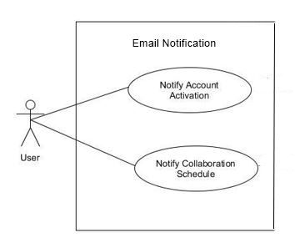

Figure 12. System Use Case of Email Notification

Use Case Description

Use Case Name: Notify Account Notification

Purpose: To notify and activate the account of the user

Triggering Actor: User

Benefiting Actor: User

Pre-Condition: The user will submit account registration

Post-Condition: The user will receive an email notification

Steps:

|  |  |
| --- | --- |
| User | System |
| 1. Click the Register button   3.) The user will fill out all the needed information  4.) Click the Signup button, after filling out the information | 2.) The system will load the Register UI form.  4.1 If Signup click is true, the system will redirect to ‘Account Setting’ page and send an email notification to the email address that the user provided else  4.2 The system will show a message “There is an error. Please check the information you provided”. |

Use Case Description

Use Case Name: Notify Collaboration Schedule

Purpose: To notify the user for the upcoming collaboration schedule

Triggering Actor: User

Benefiting Actor: User

Pre-Condition: The other user will accept the collaboration request

Post-Condition: Both users will receive an email for collaboration schedule

Steps:

|  |  |
| --- | --- |
| User | System |
| 1. Click the user’s profile picture in the navigation     3.) Clicks the ‘Profile’ link.  4.) The user will scroll down and proceed to Appointment Request.  5.) Choose a user from the list and user clicks ‘Accept’ or ‘Reject’ | 2.) Submenu will show up with the clickable links [Profile, My Account, Logout].  3.) The system will load the Profile of the user together with list of users (if exist) who made an appointment request to this user. This list has an option to ‘Accept’ or ‘Reject’ an appointment.  6.) Either ‘Accept or Reject’ button is clicked, a dialog box will appear to confirm the action.  6.1 If yes click is true, then the appointment will be accepted and an email notification will be sent to a user after confirmation accepted or rejected else  6.2 Dialog box will be close |

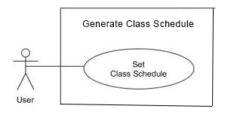

Figure 13. System Use Case of Class Schedule

Use Case Description

Use Case Name: Set Class Schedule

Purpose: To choose and set a schedule request to teacher

Triggering Actor: User

Benefiting Actor: User

Pre-Condition: The user will accept the appointment request of another user

Post-Condition: Both users will be added to the booking lists

Steps:

|  |  |
| --- | --- |
| User | System |
| 1. Click the Profile   3.) In Pending Appointment section, the user will click Accept or Reject the Appointment request.  4.) User will click the Accept or Reject button  4.1.1) User will click Yes or No button    4.2.1) User will click Yes or No button   1. Clicks ‘Pay now’ or ‘Cancel’ button   5.1.1) Clicks ‘Pay’ or ‘Cancel’ button | 2.) The system will redirect to User Profile page.  4.1 If the user click Accept is true, the system will show appointment confirmation modal message “Are you sure you want to accept this appointment” else  4.1.2 By default, an appointment has a status of ’Pending’. If user click Yes button is true, the Appointment status will be updated to ‘Accepted’ status and it will not be shown in Appointment Request anymore since it is already accepted then a ‘Pay now’ button will appear else  4.1.3) The system will close the appointment confirmation dialogue and Appointment request will remain.  4.2) If the user click Rejected is true, the system will show appointment confirmation modal message “Are you sure you want to reject this appointment”    4.2.2) By default, an appointment has a status of ‘Pending’. If user click Yes button is true, the Appointment status will be updated to ‘Rejected status and it will not be shown in Appointment Request anymore since it is already accepted else  4.2.3) The system will close the appointment confirmation dialogue and Appointment request will remain    5.1) If the user clicks ‘Pay now’ button is true, a modal will pop up displaying all the bill/payment details with two buttons ‘Cancel’ or ‘Pay’ else  5.1.2) If User clicks ‘Pay’ is true, then user will be booked and the system will generate a session link to make a class schedule then the appointment status will be updated into ‘Paid’ then ‘Pay now’ button will be hidden else.  5.1.3) the bill modal will be hidden from the page.  5.2.) Appointment will be deleted |

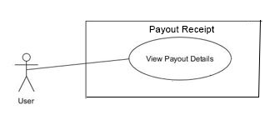

Figure 14. System Use Case of Payout Receipt

Use Case Description

Use Case Name: View Payout details

Purpose: To view the payout transaction details

Triggering Actor: User

Benefiting Actor: User

Pre-Condition: The user wants to view the payout details

Post-Condition: The user view the payout details

Steps:

|  |  |
| --- | --- |
| User | System |
| 1. Click the Profile   3.) In Pending Appointment section, the user will click the Pay Now button | 2.) The system will redirect to User Profile page.  4.) The system will show a Payout Bill of the Appointment and the system will be save the payment. |

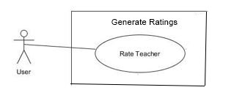

Figure 15. System Use Case of Ratings

Use Case Description

Use Case Name: Rate Teacher

Purpose: To make a rating for the other user

Triggering Actor: User

Benefiting Actor: User

Pre-Condition: The user wants to rate the other user

Post-Condition: The user rated the other user

Steps:

|  |  |
| --- | --- |
| User | System |
| 3.) User click and provide ratings of the other user  4.) User will click Submit | 1.) The system will end the Appointment session if the time exceeded.  2.) The system will show the rating UI and cannot be closed.  5.) The system will save the ratings. |

Database Schema

A database schema is the skeleton structure that represents the logical view of the entire database. A database schema is typically created by a database designer to assist programmers whose software will interface with the database.

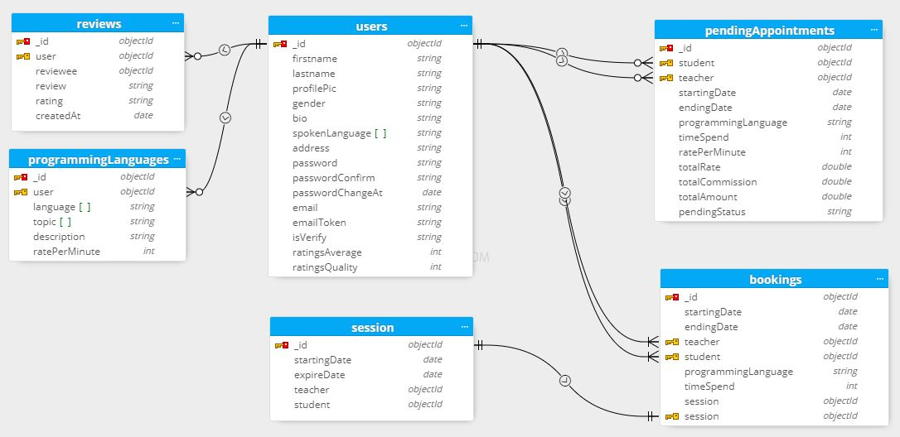

Figure 17. Database Schema of Collaborative Code Learning Environment using MERN Stacks

Implementation Strategies

Before implementing the system, the researcher investigated various types of online education platforms, such as Google Meet and Zoom. Furthermore, they investigated the favorable impact of collaborative online education via a digital platform such as a computer. Students will be able to comprehend programming more readily with the help of this collaborative platform